Scoreboard Procedure
Fields 1 & 3
- The Controllers are in the office in the closet above the desk
- For field 3
  - There is a light switch in the box on the pole under the scoreboard to turn the scoreboard on and off. Pictured below.
  - 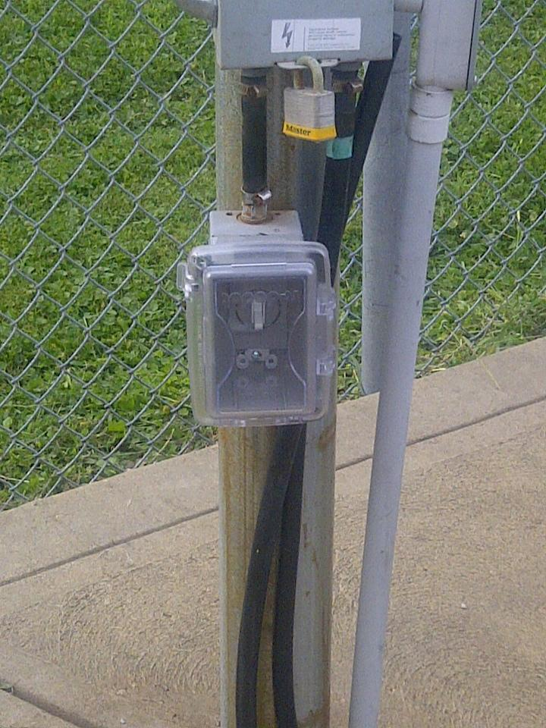
- For field 1
  - There is a light switch in the beige box on the pole under the scoreboard to turn the scoreboard on and off. Pictured below.
  - 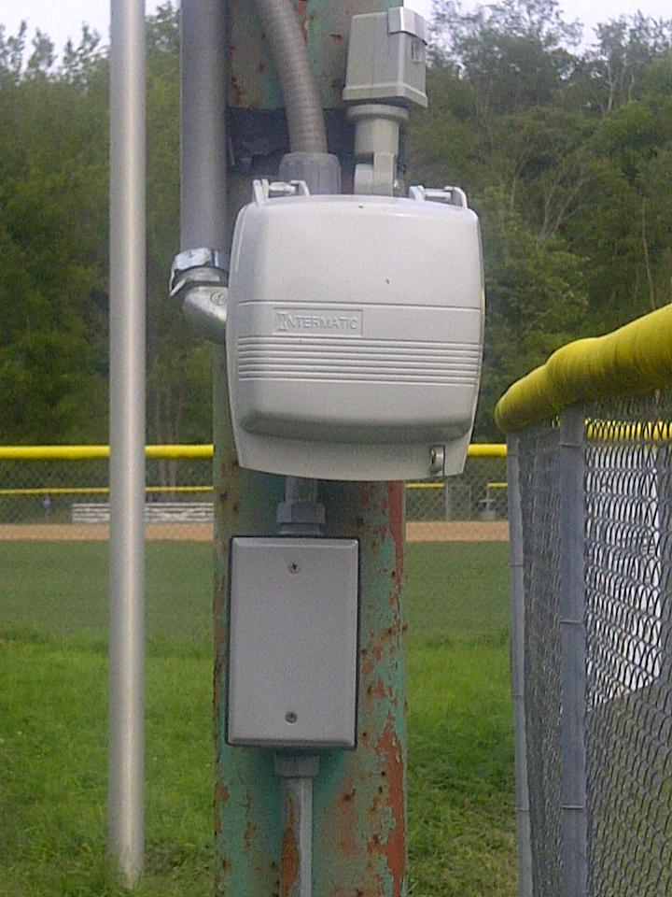
- After the game, put the controllers back in the office. If the office is locked and a board member is not still at the complex, leave the controllers on the shelf outside the office.

